ASSIGNMENT NO.7: Subqueries and Nested Queries

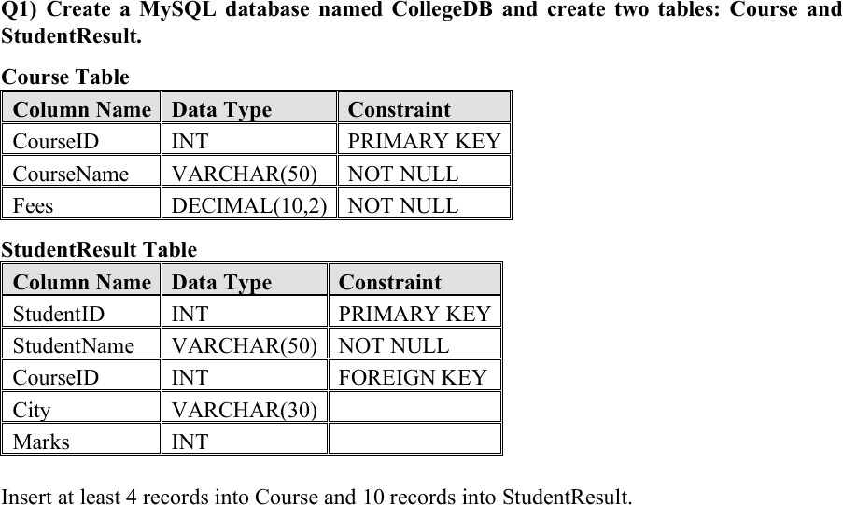
QUERY
-- Select existing database USE CollegeDB;

-- Q1) CREATE TABLES

CREATE TABLE Course_Subquery ( CourseID INT PRIMARY KEY, CourseName VARCHAR(50) NOT NULL, Fees DECIMAL(10,2) NOT NULL
);
-- StudentResult table for Assignment 7 CREATE TABLE StudentResult_Subquery (
StudentID INT PRIMARY KEY, StudentName VARCHAR(50) NOT NULL, CourseID INT,

City VARCHAR(30),
Marks INT,
FOREIGN KEY (CourseID) REFERENCES Course_Subquery(CourseID)
);

-- Insert 4 records into Course table INSERT INTO Course_Subquery (CourseID, CourseName, Fees) VALUES
(101, 'BSc IT', 45000.00),
(102, 'BCA', 40000.00),
(103, 'BSc CS', 42000.00),
(104, 'Data Science', 55000.00);

-- Insert 10 records into StudentResult table INSERT INTO StudentResult_Subquery (StudentID, StudentName, CourseID, City, Marks) VALUES
(1, 'Rahul Sharma', 101, 'Mumbai', 78),
(2, 'Priya Patil', 102, 'Pune', 85),
(3, 'Aman Verma', 103, 'Nashik', 67),
(4, 'Sneha Joshi', 101, 'Mumbai', 91),
(5, 'Karan Mehta', 102, 'Thane', 74),
(6, 'Neha Shah', 101, 'Pune', 88),
(7, 'Rohan Desai', 103, 'Mumbai', 69),
(8, 'Meera Kulkarni', 102, 'Nashik', 82),
(9, 'Arjun Nair', 101, 'Thane', 59),
(10, 'Divya More', 102, 'Mumbai', 93);

SELECT * FROM Course_Subquery; SELECT * FROM StudentResult_Subquery;

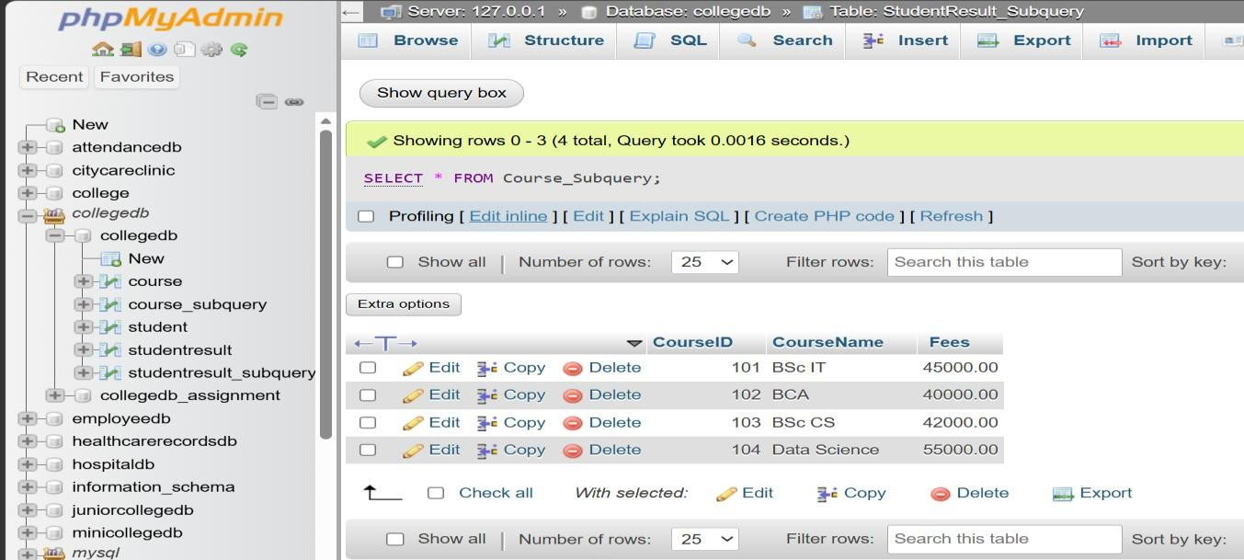
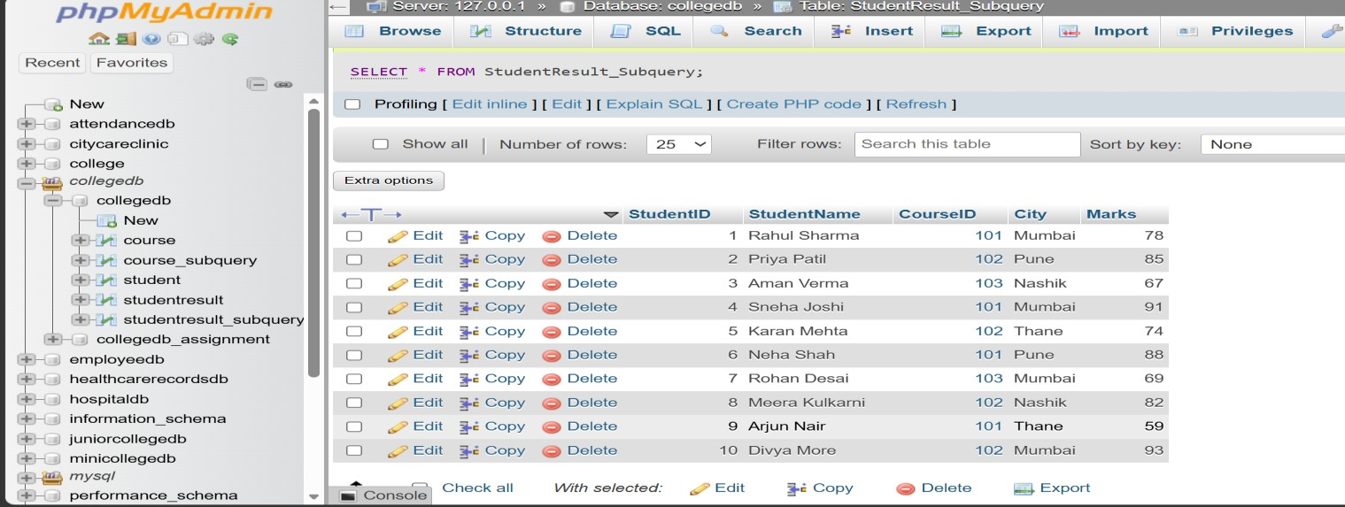

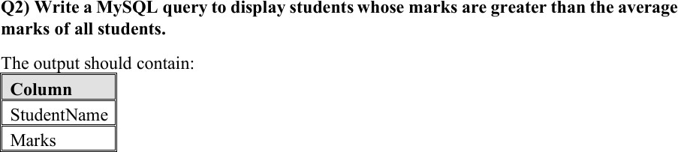

QUERY
SELECT StudentName, Marks FROM StudentResult_Subquery WHERE Marks > (
SELECT AVG(Marks)
FROM StudentResult_Subquery
);

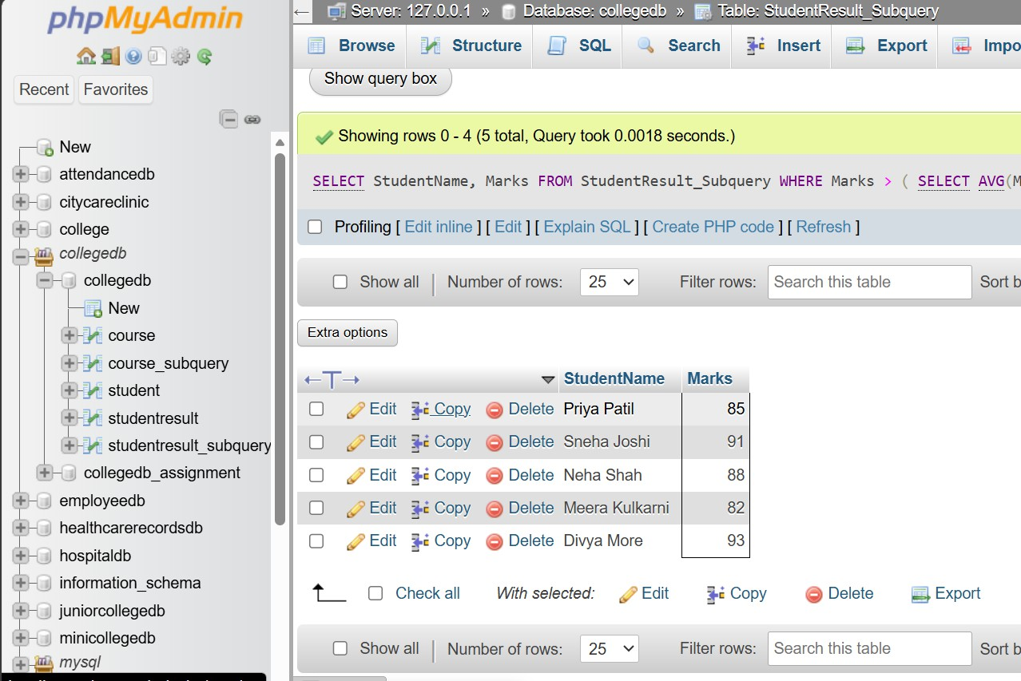

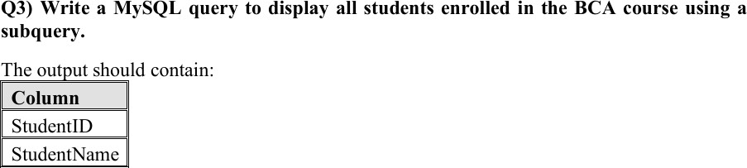
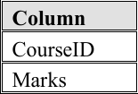

QUERY
SELECT StudentID, StudentName, CourseID, Marks FROM StudentResult_Subquery
WHERE CourseID = ( SELECT CourseID
FROM Course_Subquery WHERE CourseName = 'BCA'
);

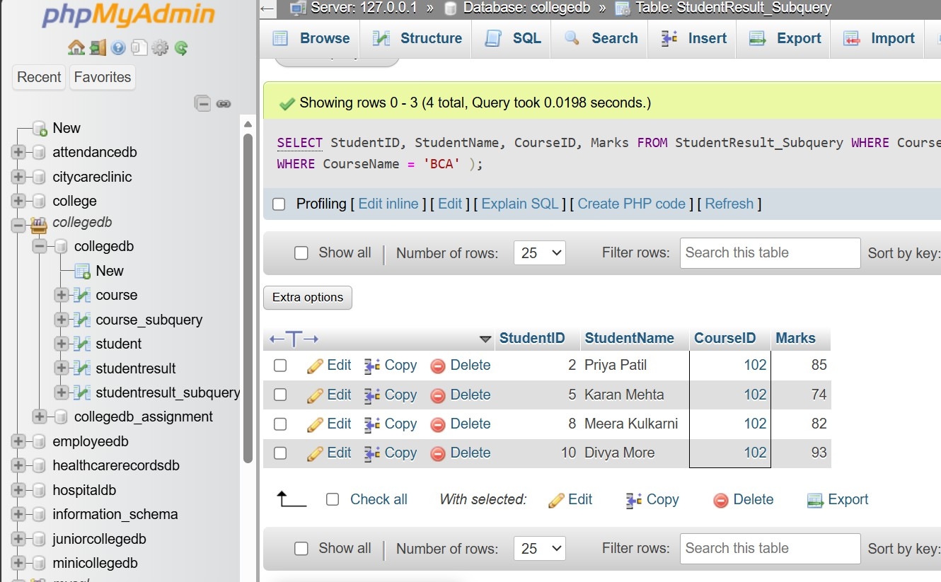

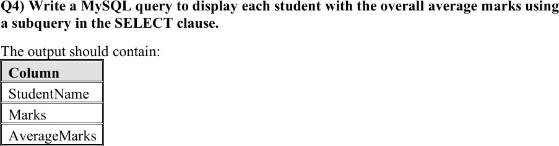

QUERY
SELECT StudentName, Marks, (
SELECT AVG(Marks)
FROM StudentResult_Subquery
) AS AverageMarks
FROM StudentResult_Subquery;

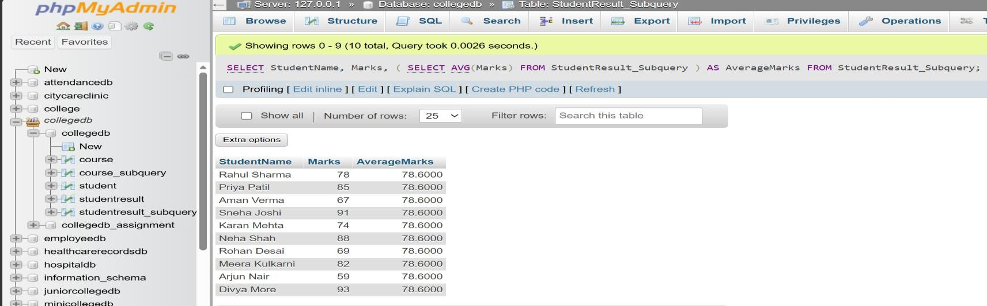

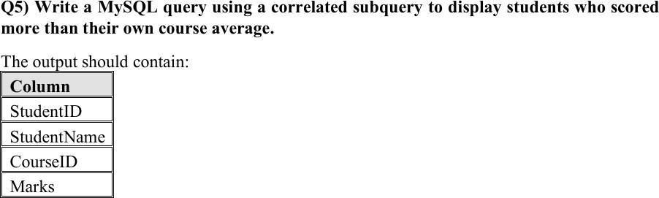

QUERY
SELECT StudentID, StudentName, CourseID, Marks FROM StudentResult_Subquery S1
WHERE Marks > ( SELECT AVG(Marks)

FROM StudentResult_Subquery S2 WHERE S2.CourseID = S1.CourseID
);

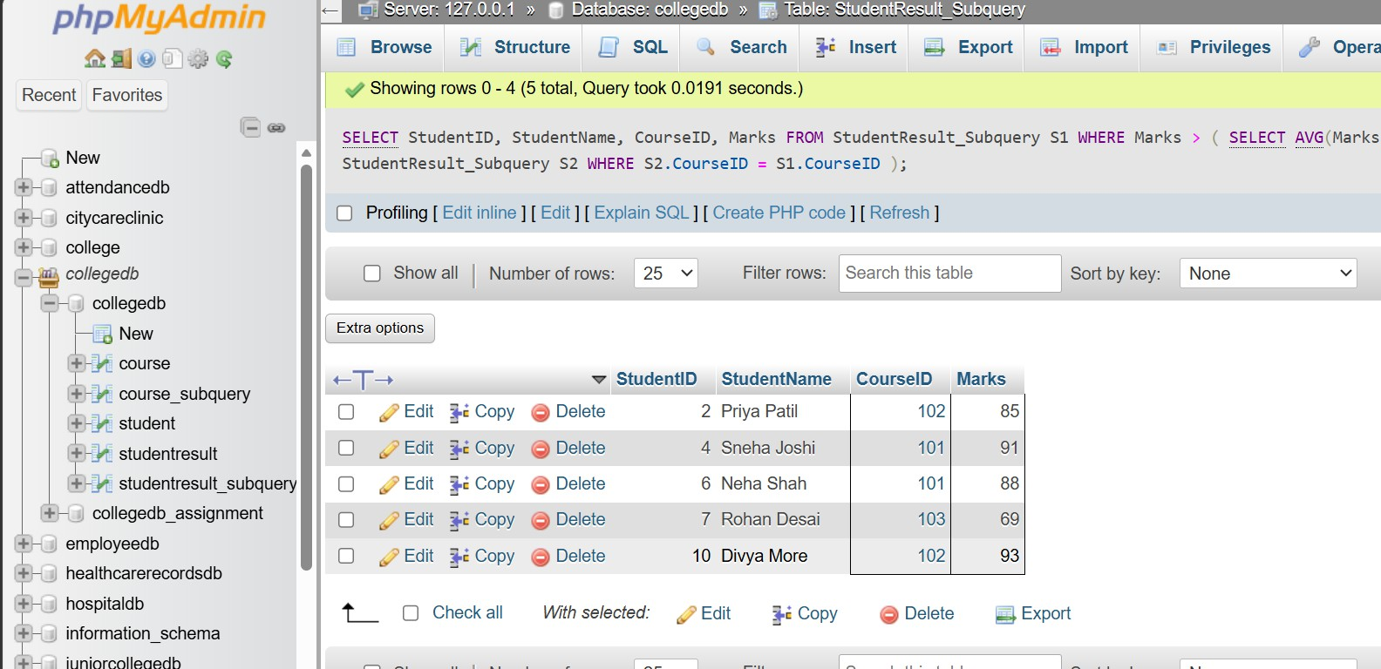

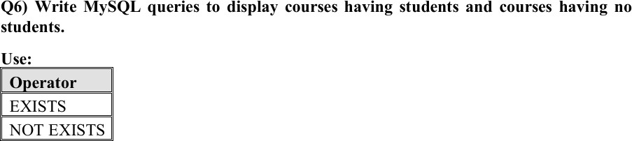

QUERY
SELECT CourseID, CourseName FROM Course_Subquery C WHERE EXISTS (

SELECT 1
FROM StudentResult_Subquery S WHERE S.CourseID = C.CourseID
);

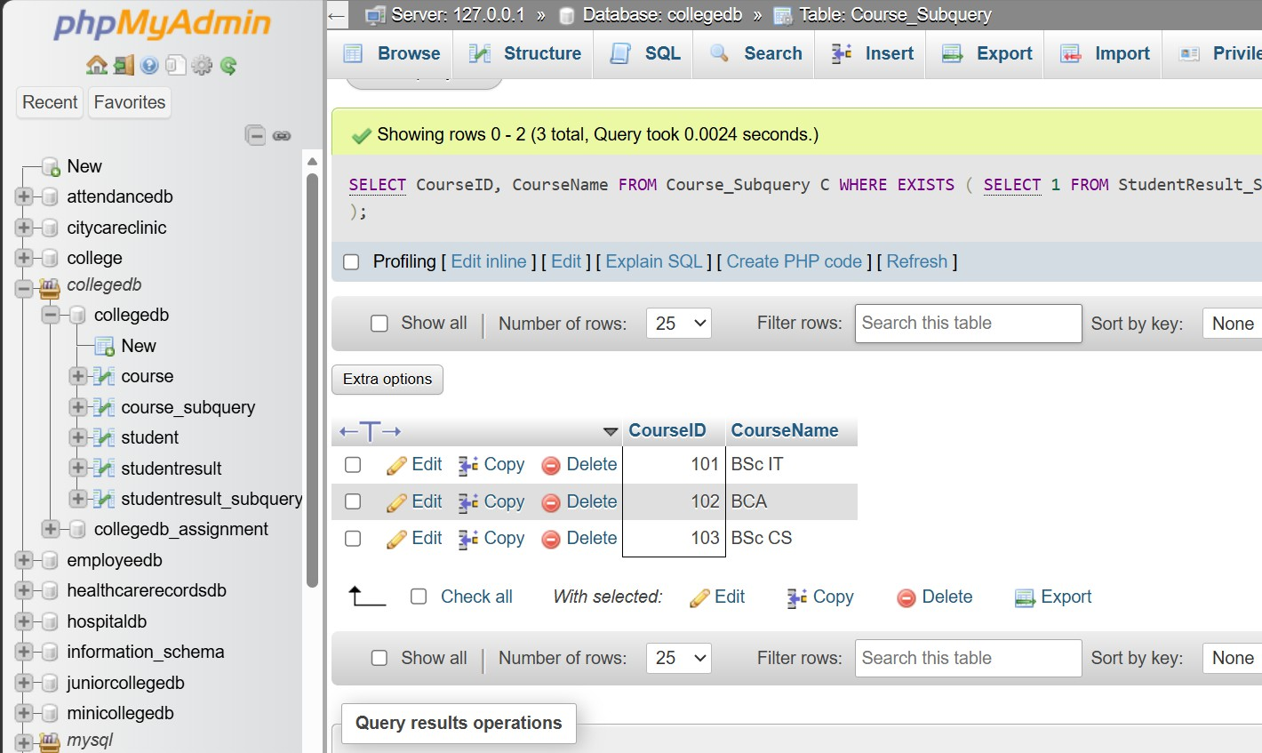

-- Q6) COURSES HAVING NO STUDENTS
-- USING NOT EXISTS
-- ============================================

QUERY
SELECT CourseID, CourseName FROM Course_Subquery C WHERE NOT EXISTS (

SELECT 1
FROM StudentResult_Subquery S WHERE S.CourseID = C.CourseID
);

